**MongoDB Lab Assignments by RAJ KHAJURIYA**

**MongoDB Exercise in mongo shell**

Connect to a running mongo instance, use a database named **mongo_practice**.

Document all your queries in a javascript file to use as a reference.

**Insert Documents**

Insert the following documents into a **movies** collection.

title : Fight Club

writer : Chuck Palahniuko

year : 1999

actors : [

Brad Pitt

Edward Norton

]

title : Pulp Fiction

writer : Quentin Tarantino

year : 1994

actors : [

John Travolta

Uma Thurman

]

title : Inglorious Basterds

writer : Quentin Tarantino

year : 2009

actors : [

Brad Pitt

Diane Kruger

Eli Roth

]

title : The Hobbit: An Unexpected Journey

writer : J.R.R. Tolkein

year : 2012

franchise : The Hobbit

title : The Hobbit: The Desolation of Smaug

writer : J.R.R. Tolkein

year : 2013

franchise : The Hobbit

title : The Hobbit: The Battle of the Five Armies

writer : J.R.R. Tolkein

year : 2012

franchise : The Hobbit

synopsis : Bilbo and Company are forced to engage in a war against an array of combatants and keep the Lonely Mountain from falling into the hands of a rising darkness.

title : Pee Wee Herman's Big Adventure

title : Avatar

**Query / Find Documents**

query the **movies** collection to

**1. get all documents**

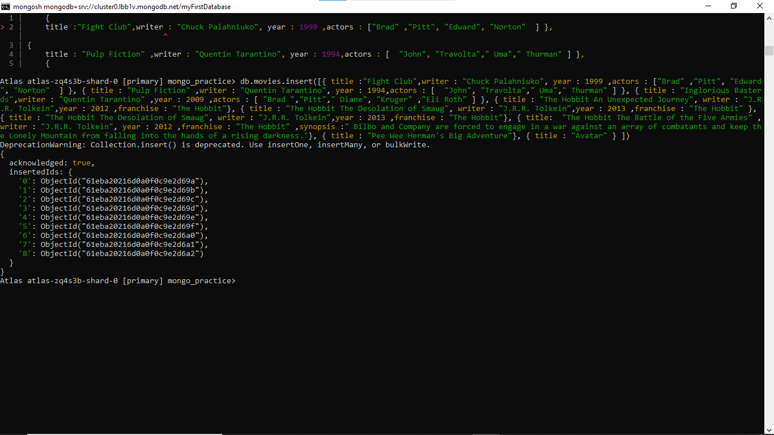

**2. get all documents with writer set to "Quentin Tarantino"**

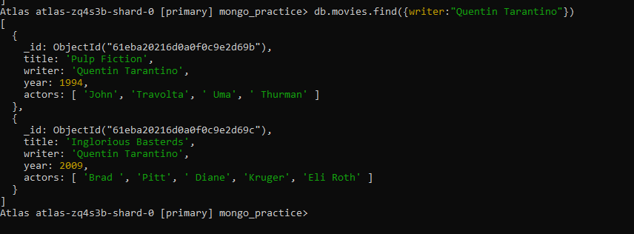

**3. get all documents where actors include "Brad Pitt"**

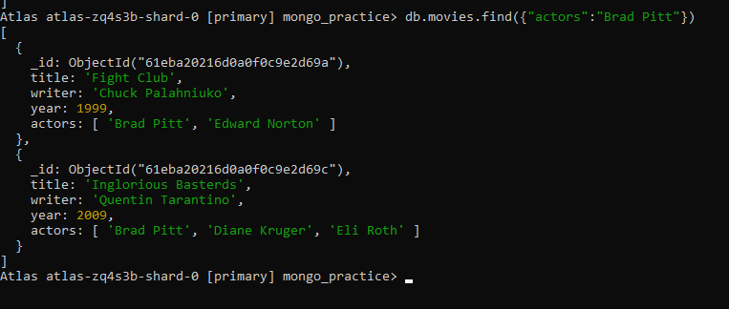

**4. get all documents with franchise set to "The Hobbit"**

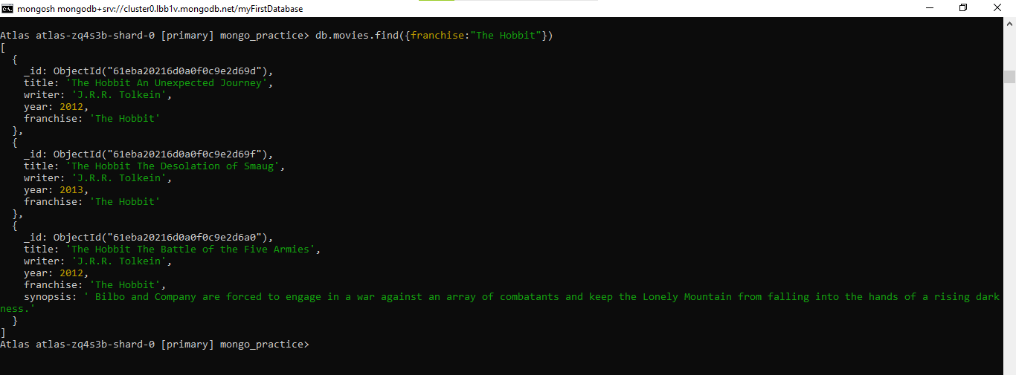

**5. get all movies released in the 90s**

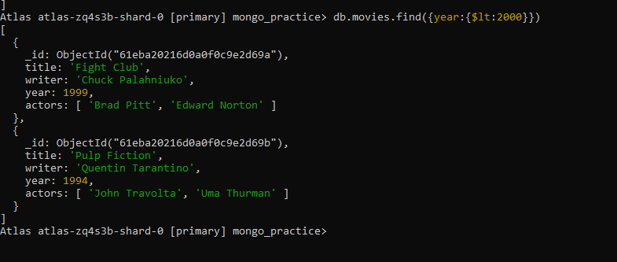

**6. get all movies released before the year 2000 or after 2010**

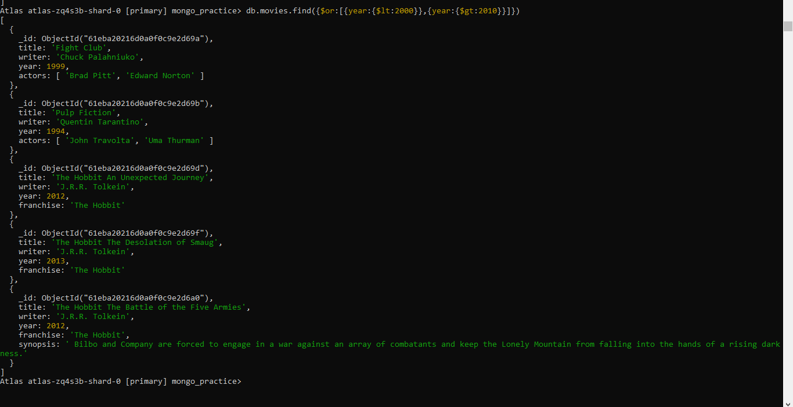

**Update Documents**

**1. add a synopsis to "The Hobbit: An Unexpected Journey" : "A reluctant hobbit, Bilbo Baggins, sets out to the Lonely Mountain with a spirited group of dwarves to reclaim their mountain home - and the gold within it - from the dragon Smaug."**

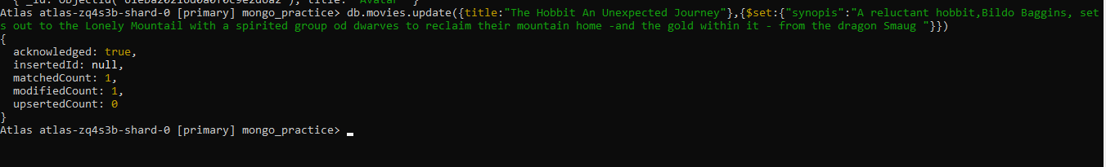

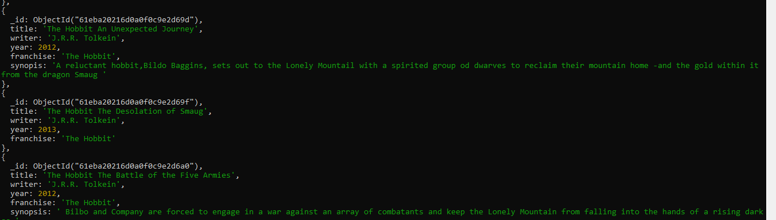

**2. add a synopsis to "The Hobbit: The Desolation of Smaug" : "The dwarves, along with Bilbo Baggins and Gandalf the Grey, continue their quest to reclaim Erebor, their homeland, from Smaug. Bilbo Baggins is in possession of a mysterious and magical ring."**

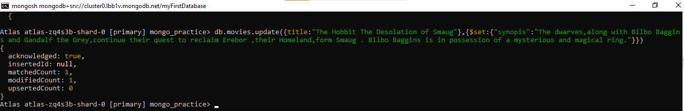

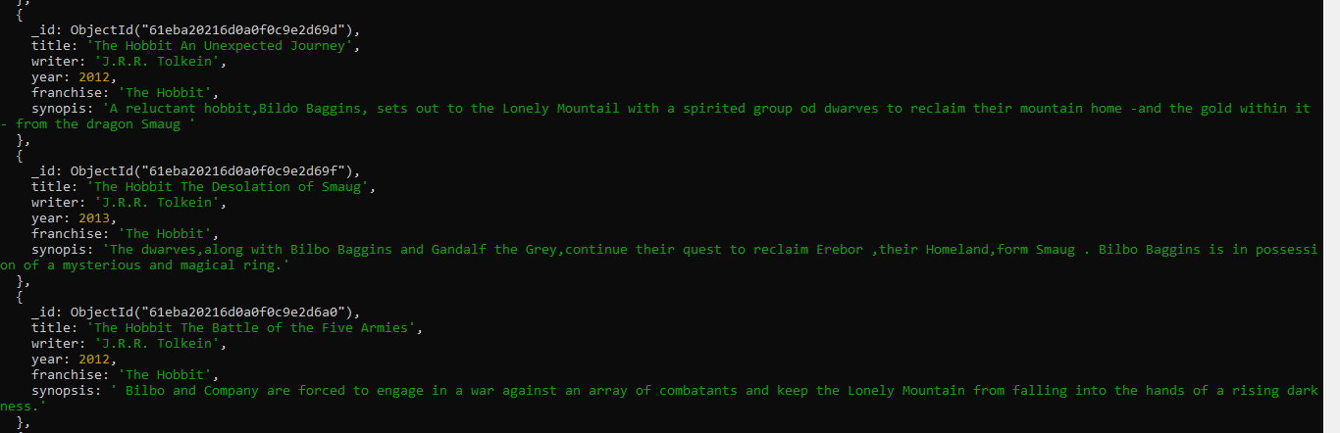

**Text Search**

**1. find all movies that have a synopsis that contains the word "Bilbo"**

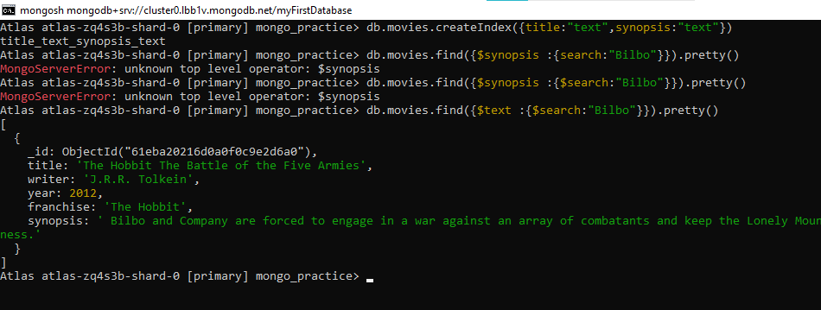

**2. find all movies that have a synopsis that contains the word "Gandalf"**



**3. find all movies that have a synopsis that contains the word "Bilbo" and not the word "Gandalf"**

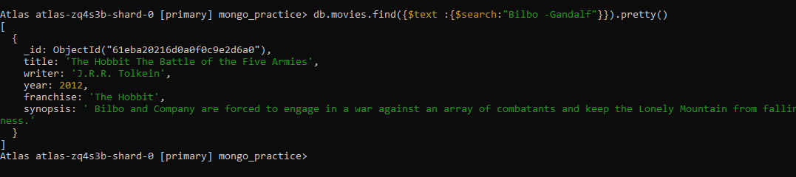

**4. find all movies that have a synopsis that contains the word "dwarves" or "hobbit"**

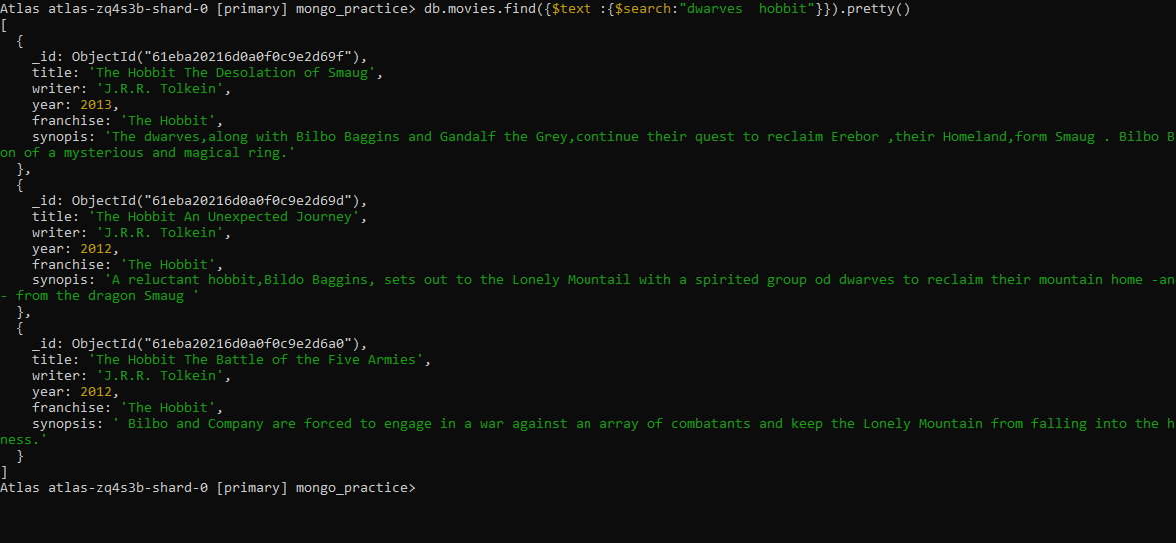

**5. find all movies that have a synopsis that contains the word "gold" and "dragon"**

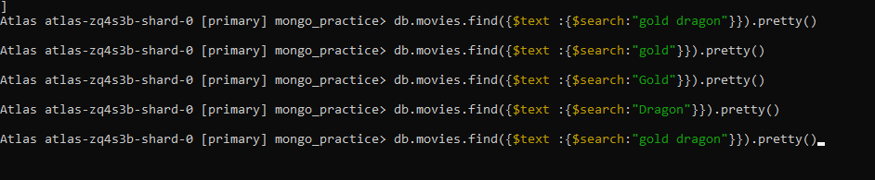

**Delete Documents**

**1. delete the movie "Pee Wee Herman's Big Adventure"**



**2. delete the movie "Avatar"**



**Relationships**

Insert the following documents into a **users** collection

username : GoodGuyGreg

first_name : "Good Guy"

last_name : "Greg"

username : ScumbagSteve

full_name :

first : "Scumbag"

last : "Steve"

Insert the following documents into a **posts** collection

username : GoodGuyGreg

title : Passes out at party

body : Wakes up early and cleans house

username : GoodGuyGreg

title : Steals your identity

body : Raises your credit score

username : GoodGuyGreg

title : Reports a bug in your code

body : Sends you a Pull Request

username : ScumbagSteve

title : Borrows something

body : Sells it

username : ScumbagSteve

title : Borrows everything

body : The end

username : ScumbagSteve

title : Forks your repo on github

body : Sets to private

Insert the following documents into a **comments** collection

username : GoodGuyGreg

comment : Hope you got a good deal!

post : [post_obj_id]

where [post_obj_id] is the ObjectId of the posts document: "Borrows something"

username : GoodGuyGreg

comment : What's mine is yours!

post : [post_obj_id]

where [post_obj_id] is the ObjectId of the posts document: "Borrows everything"

username : GoodGuyGreg

comment : Don't violate the licensing agreement!

post : [post_obj_id]

where [post_obj_id] is the ObjectId of the posts document: "Forks your repo on github

username : ScumbagSteve

comment : It still isn't clean

post : [post_obj_id]

where [post_obj_id] is the ObjectId of the posts document: "Passes out at party"

username : ScumbagSteve

comment : Denied your PR cause I found a hack

post : [post_obj_id]

where [post_obj_id] is the ObjectId of the posts document: "Reports a bug in your code"

**Querying related collections**

**1. find all users**

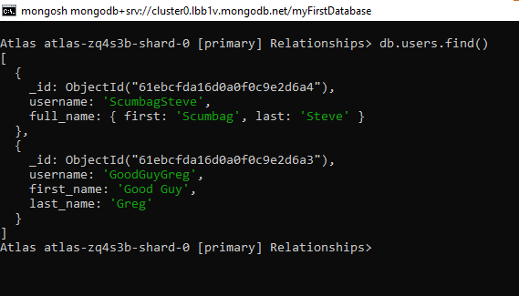

**2. find all posts**

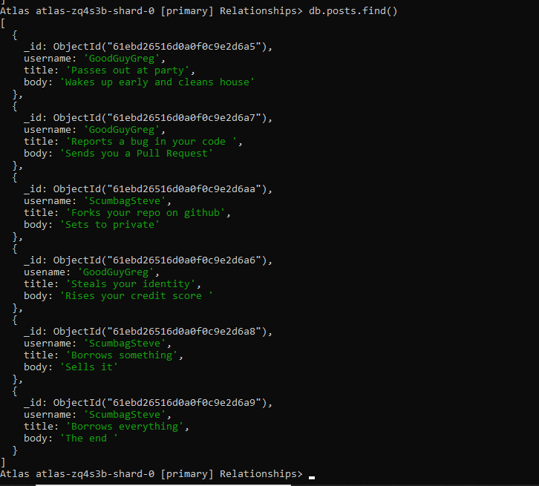

**3. find all posts that was authored by "GoodGuyGreg"**

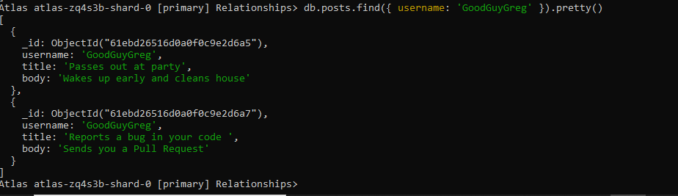

**4. find all posts that was authored by "ScumbagSteve"**

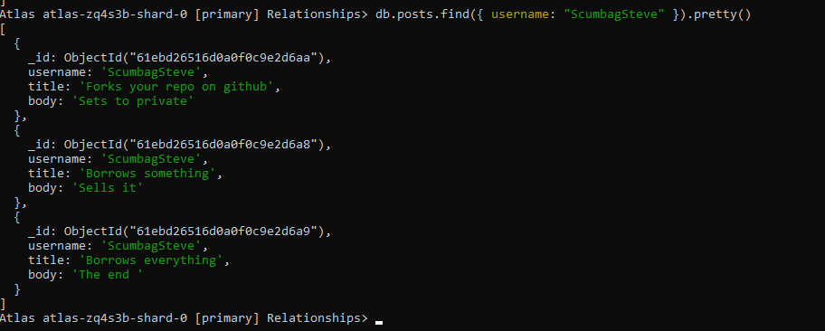

**5. find all comments**

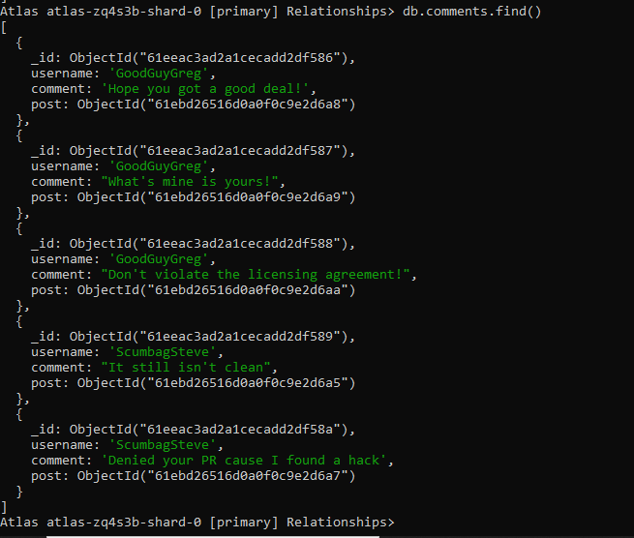

**6. find all comments that was authored by "GoodGuyGreg"**

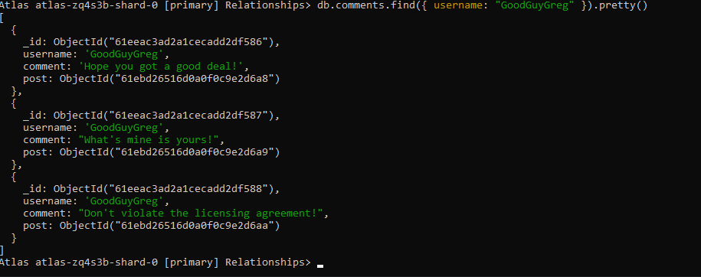

**7. find all comments that was authored by "ScumbagSteve"**

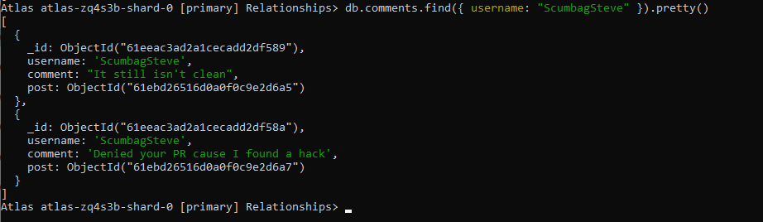

**8. find all comments belonging to the post "Reports a bug in your code"**

